
Dalgo+Superset


<NGO Name>
Proposed Approach
<Month + Year>
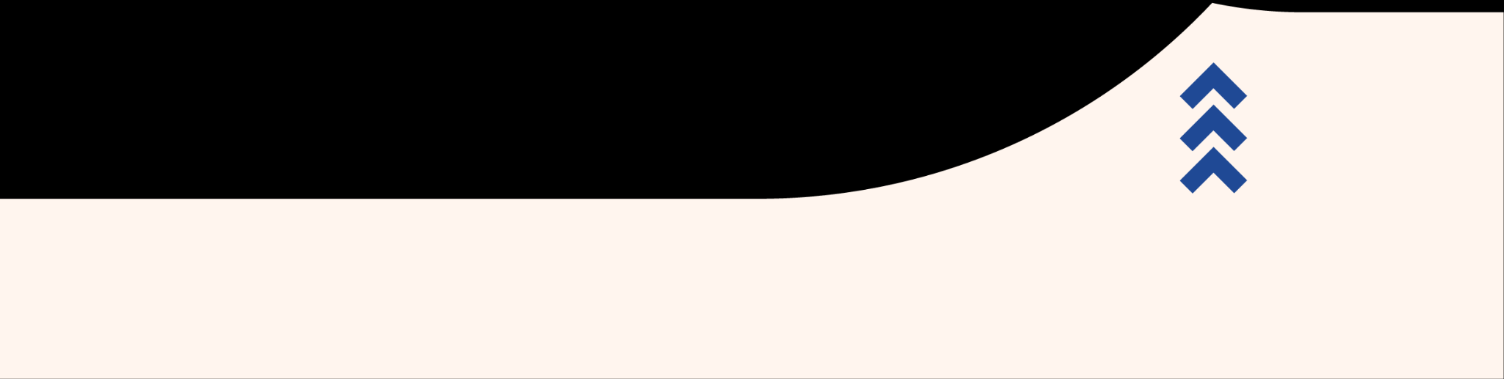

Organization Background and Tech Needs

Background

<Paragraph on organization background>

Technical Stack
<Paragraph about how the NGO is currently using technology>

Current challenges

<Paragraph about current technical challenges>

Proposed Approach for Engagement

High Level Goals

<High Level Goals for the Engagement>

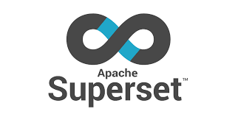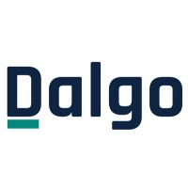

Source 1

Data Warehouse

Persona 2
Analysis and Operational Dashboards

Source 2

Persona 1

Persona 4

Persona 3

High level Project Plan - Phase I
<Sample of what the table should look like>

Deliverables | Timeframe | Outputs | Hours
1 | March 17 -Apr 11 | - Setup production deployment of CMHLP on Dalgo and Superset including Superset Usage dashboards, Elementary Report  - Build the PO dashboard and the transformations associated with it | 50
2 | Apr 14 - May 12 | - Build the champions dashboard and the transformations associated with it. These will public dashboard and | 50
3 | May 12 - June 13 | - Build the CF dashboard along with the transformations associated | 50
4 | Jun 13 - Jul 20 | - Work on Feedback and wrap up any pending dashboard work  - Documentation of Superset dashboards and all dbt data transformation work for CMHLP  - Training of CMHLP internal staff on Dalgo, Superset and dbt | 50

Requirements Document link - <Insert link to requirements document>

Planning Assumptions
- Approximate estimations are quoted in hours. We always bill on actuals and if there are distinctive scope changes that prevent us from completing work in particular quoted hours we will provide this information well in advance of the hours running out.
- <Add in any other assumptions>

Cost
All consulting work will be done at the cost of INR 2500 an hour accounting for an overall estimated consulting effort for Phase I coming to 200 hours amounting to INR 500000 .
Dalgo platform SaaS cost with Superset (annual) will be INR 252000 . Dalgo platform will provide all infrastructure for ingestion and transformation for data coupled with hosting Superset for data visualizations and insights.
All quoted amounts are liable to tax at 18% GST.
Note: Data warehouse (PostgreSQL) will be hosted by <NGO Name>

SaaS Data Platform
Dalgo + Superset estimated costs:
- Data Platform infrastructure (Dalgo) with Superset : Base cost of platform using shared servers and maintained SaaS platform service with SuperSet : INR 252000/yr
- Data Warehouse: Hosted on AWS by CMHLP - $300/yr (is dependent on the volume of data and query processing)
- Taxes: 18% GST

Notes for Data Warehouse:
- AWS Infrastructure non profit credits can give <NGO> approximately $1000 of credits. Refer, https://bigtech.nasscomfoundation.org/node/7472
- Approximate spend post the end of free access period for AWS RDS is $25/month
- Add a safety margin of 20% to account for new requirements and needs for budgeting purposes.

Addendum - Key Questions from <NGO Name>
Meeting Notes: <link to meeting notes>

<Questions and Answers>

